## DESIGN OF RIVETED JOINTS FOR

## STRUCTURAL APPLICATIONS

**A MAJOR PROJECT REPORT SUBMITTED IN THE PARTIAL FULFILLMENT OF**

**REQUIREMENT FOR THE AWARD OF**

**DEGREE OF**

**BACHELOR OF ENGINEERING**

**IN**

**MECHANICAL ENGINEERING**

**SUBMITTED TO**

**RAJIV GANDHI PROUDYOGIKI VISHWAVIDYALAYA**

**BHOPAL (M.P.)**



**SUBMITTED BY**

**PRANAY SINGH RAJAT JOSHI**

**(0103ME141104) (0103ME141114)**

**LALCHAND KUMAR PRANAY MALVIYA**

**(0103ME141078) (0103ME141103)**

**UNDER THE GUIDANCE OF**

**Dr. R. G. Patil**

**PROF. MECHANICAL DEPARTMENT**



**DEPARTMENT OF MECHANICAL ENGINEERING**

**LAKSHMI NARAIN COLLEGE OF TECHNOLOGY**

**BHOPAL (M.P.)**



**LAKSHMI NARAIN COLLEGE OF TECHNOLOGY**

**Bhopal (M.P.)**

**CANDIDATE’S DECLARATION**

I hereby declare that this Major Project Report entitled **“DESIGN OF RIVETED JOINTS FOR STRUCTURAL APPLICATIONS”** is my own work conducted under the supervision of **Dr. R. G. Patil** of Mechanical Engineering Department, **Lakshmi Narain College of Technology, Bhopal, M.P**.

I further declare that to the best of my knowledge and belief that this report does not contain any part of work that has been submitted for the award of any degree either in this university or in any other university/Deemed university without proper citation.

PRANAY SINGH

0103ME141104

RAJAT JOSHI

0103ME14114

LALCHAND KUMAR

0103ME141078

PRANAY MALVIYA

0103ME141103



**LAKSHMI NARAIN COLLEGE OF TECHNOLOGY**

**Bhopal (M.P.)**

**CERTIFICATE**

This is to certify that the Major Project Report entitled **“DESIGN OF RIVETED JOINTS FOR STRUCTURAL APPLICATIONS”** is the original project work carried out independently by **PRANAY SINGH (0103ME141104), LALCHAND KUMAR (0103ME141078), RAJAT JOSHI (0103ME141114), PRANAY MALVIYA (0103ME141103),**  student of Bachelor of Engineering in Mechanical Engineering from Rajiv Gandhi Proudyogiki Vishwavidyalaya, Bhopal for the partial fulfilment of the requirement for the award of the degree of Bachelor of Engineering and this report has not formed previously the basis for the award of any degree, diploma or any other similar title according to our knowledge.

**Guided By: Approved By:**

DR. R. G. PATIL DR. SHAILENDRA DIWEDI

PROFESSOR HEAD OF DEPARTMENT

DEPARTMENT OF DEPARTMENT OF

MECHANICAL ENGINEERING MECHANICAL ENGINEERING



**LAKSHMI NARAIN COLLEGE OF TECHNOLOGY**

**Bhopal (M.P.)**

**APPROVAL CERTIFICATE**

This Major Project work entitled **“DESIGN OF RIVETED JOINTS FOR STRUCTURAL APPLICATIONS”** being submitted by **PRANAY SINGH (0103ME141104), PRANAY MALVIYA (0103ME141103), RAJAT JOSHI (0103ME141114), LALCHAND KUMAR (0103ME141078)** has been examined by us and is hereby approved for the award of degree of Bachelor of Engineering in Mechanical Engineering which has been submitted to Rajiv Gandhi Proudyogiki Vishwavidyalaya, Bhopal (M.P.).

**Internal Examiner External Examiner**

**Date: Date:**

## ACKNOWLEDGEMENT

Completing a task is never a one-man effort. It is often the result of valuable contribution of a number of individuals, in direct or indirect manner that help in shaping and achieving an objective. This acknowledgement is nothing but a small token of gratitude in recognition of their help in this endeavour.

It is immense pleasure to express my deepest sense of gratitude and sincere thanks to my highly respected and esteemed Dr. Shailendra Diwedi, Prof. & Head Dept. Of mechanical engineering. L.N.C.T, Bhopal, for their valuable guidance, encouragement and help for this work. Their useful suggestion for this whole work and co-operative behaviour are gratefully acknowledged.

I express my deep sense of gratitude to **PROF. Dr. ASHOK RAI**, O.S.D L.N.C.T, Bhopal & **Dr. Rakesh Mowar**, Principal L.N.C.T, Bhopal (M.P.) for their blessings and encouragement.

I also express my sincere thanks to all the staff members of department of mechanical engineering L.N.C.T, Bhopal. For their cooperation in my work.

I would like to express thanks to my parents**,** without their encouragement, love and blessing I would not have reached this level.

PRANAY SINGH

0103ME141104

RAJAT JOSHI

0103ME141114

LALCHAND KUMAR

0103ME141078

PRANAY MALVIYA

0103ME141103

**Table of Content**

|  |  |  |
| --- | --- | --- |
| **S. NO.** | **CONTENT** | **PAGE NO.** |
| 1 | Abstract | 7 |
| 2 | List Of Symbols, Abbreviations And Nomenclature | 8 |
| 3 | Introduction | 9 |
| 4 | Brief Description On Types Of Riveted Joints | 11 |
| 5 | Design Procedure For Riveted Joints (Structural Application) | 13 |
| 6 | Prerequisites & Installation Of Program | 15 |
| 7 | Back-End Working/Algorithm Used In Coding | 22 |
| 8 | Limitations Of The Program | 24 |
| 9 | References | 25 |

**Abstract**

The joints used in mechanical assemblies are classified into two groups—permanent and separable. Permanent joints are those joints which cannot be disassembled without damaging the assembled parts. Riveted joints are called permanent joints. Rigorous calculations are needed to design riveted joints for structural application on the basis of given material, type of riveting and its failure. So, we designed a user-friendly application in which user only have to select material of rivet or user can provide values of different strengths, thickness of plate used, type of riveting and its pattern and in output the design of respected riveted joint will be displayed along with all of its important parameters will be provided to the user. In this way a lot of time can be saved and even layman/unexperienced person can find the standard dimensions of the rivets which is to be purchased for the purpose of making joint along with the practical design view related to it.

For designing the application, we used Python-3.6.4 software. First, we code various formulas for designing the riveted joints for structural purpose and then we provided a user interface for inputs and outputs. We then started building four different CAD models of Lap joint and butt joint with chain and zigzag riveting with different variables and formula. Then, we link the modelling software SolidWorks with Python via MS-EXCEL. The Interface/coding is such that the parameters that are being calculated as per the user input will be written on the excel file automatically for respected type of joint which is linked with modelling software. Hence, the model will be displayed accordingly.

Using this application, we eliminate the human error and time consumption involved in the manual calculation. It can be widely used in the different industries. We are providing with User friendly setup file for installation of program which can be installed in most of the computers.

**List of Symbols, Abbreviations and Nomenclature**

**n =** No. of rows of rivets

**t =** Thickness of base plate

**t1 =** Thickness of Cover Plate

**d =** Calculated diameter

**diameter =** Std. Diameter of Rivet

**p =** Pitch of the rivet

**pt =** Transverse pitch of the rivet

**dh =** Diameter of hole

**l =** Standard length of Rivet

**l3 =** Actual length of rivet for CAD purpose

**nop =** No of cover plates in butt joint

**St =** Tensile Strength in N/mm2

**Sc =** Compressive Strength in N/mm2

**Ss =** Shear Strength in N/mm2

**seff =** Shear efficiency

**teff =** Tearing efficiency

**ceff =** Crushing efficiency

**eff =** Joint efficiency

**Introduction**

The joints used in mechanical assemblies are classified into two groups—permanent and separable. Permanent joints are those joints which cannot be disassembled without damaging the assembled parts. Riveted and welded joints are permanent joints. riveted joints were widely used for making permanent joints in engineering applications like boilers, pressure vessels, reservoirs, ships, trusses, frames and cranes.

Primary purpose of rivet is to join two or more sheets which can be similar or dissimilar without the requirement of skilled labour. It is basically of two type – Lap joint and butt joint. Further classification of Riveted joints is shown in the figure below.

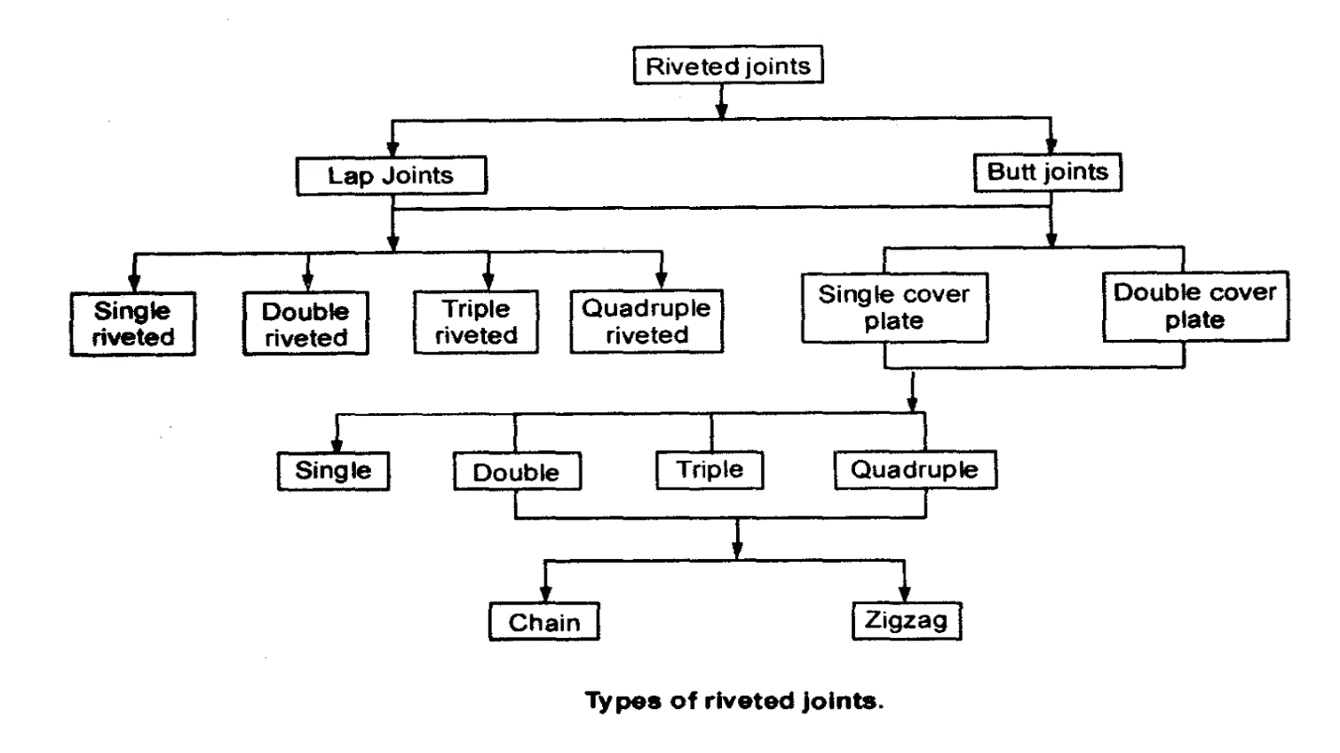

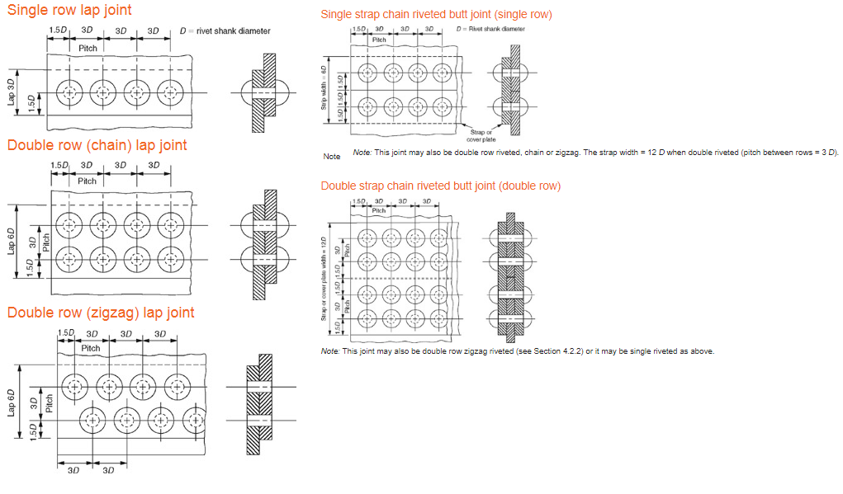

**Important Terms Used in Riveted Joints**

The following terms in connection with the riveted joints are important from the subject point of view :

**1. *Pitch*.** It is the distance from the centre of one rivet to the centre of the next rivet measured parallel to the seam . It is usually denoted by *p*.

**2. *Back pitch*.** It is the perpendicular distance between the centre lines of the successive rows. It is usually denoted by *pb*.

**3. *Diagonal pitch*.** It is the distance between the centres of the rivets in adjacent rows of zig-zag riveted joint. It is usually denoted by *pd*.

**4. *Margin or marginal pitch*.** It is the distance between the centre of rivet hole to the nearest edge of the plate. It is usually denoted by *m*.

**Brief description on Types of riveted joints**

Riveted joints used for joining the plates are classified into two groups—lap joint and butt joint. Lap joint consists of two overlapping plates, which are held together by one or more rows of rivets . Depending upon the number of rows, the lap joints are further classified into single-riveted lap joint, double-riveted lap joint or triple riveted lap joint. In double or triple riveted lap joints, the rivets can be arranged in chain pattern or zig-zag pattern. A chain riveted joint is a joint in which the rivets are arranged in such a way that rivets in different rows are located opposite to each other. A zig-zag riveted joint is a joint in which the rivets are arranged in such a way that every rivet in a row is located in the middle of the two rivets in the adjacent row.

Butt joint consists of two plates, which are kept in alignment against each other in the same plane and a strap or cover plate is placed over these plates and riveted to each plate. Placing the two plates, which are to be fastened against each other is called butting. Depending upon the number of rows of rivets in each plate, the butt joints are classified as single-row butt joint and double-row butt joint. Depending upon the number of straps, the butt joints are also classified into single-strap butt joint and double-strap butt joint. The line of action of the force acting on two plates, joined by butt joint, lies in the same plane. Therefore, there is no bending moment on the joint and no warping of the plates. This is the main advantage of butt joint compared with lap joint. The disadvantage of butt joint is the requirement of additional strap plates, which increases cost. Therefore, butt joint is costly compared with lap joint.

Rivets used in most of the applications are made of mild steel. There are two varieties of steel rivet bars—hot rolled steel rivet bar and high-tensile steel rivet bar. Rivets used in corrosive atmosphere are made of stainless steel. Rivets used for connecting non-ferrous metals and soft materials are made of copper, brass, bronze and aluminium alloys. Structural joints made of aluminium alloy sections employ duralumin rivets. When metal for the parts being joined and rivet metal have different electrochemical potentials, they form galvanic pairs and accelerate the corrosion process. Therefore, many times rivets are made of the same material as the parts being joined.

**Design procedure for riveted joints**

**(Structural application)**

1. **Decide Joint layout** as per the program.
2. **Finding rivet diameter :**

If thickness of plate is more than 8mm,

d=6*t0.5 (From Unwin’s formula)

If thickness of plate is less than 8mm,

d=(4*t*Sc)/(pi*Ss)

Standardising diameter of the rivet from PSG Design Book.

1. **Finding Shear resistance per rivet and Crushing resistance per pitch:**

we take least of these two and equate to tearing resistance to find pitch of the rivet.

if srpp<crpp

**p =** diameter+srpp/(t*St);

if crpp<srpp

**p =** diameter+crpp/(t*St);

Standardising pitch of the rivet from PSG Design Book.

1. **Finding other dimensions:**

**m =** 1.5*diameter

**pt =** 2.5*diameter (ZigZag Riveting)

**=** 3*diameter (Chain Riveting)

Find **t1** using PSG design book

Find length of the rivet l=t+1.3*diameter

Standardising the length of the rivet from PSG Design Book

1. **Finding Joint efficiency, shearing efficiency, Tearing efficiency, Crushing efficiency :**

**Joint efficiency =**

**Shearing efficiency =**

**Tearing efficiency =**

**Crushing efficiency =**

**Prerequisites & Installation of Program**

**Minimum Requirement :**

**For Design calculation only :**

* Windows XP Service pack 3 / Windows 7
* 2GB Ram
* 700MB of free HDD Space
* Any Intel or AMD x86-64 processor
* Microsoft Excel 2007 & above

**For Design calculation and Design View :**

* Windows XP Service pack 3 / Windows 7
* 2GB Ram
* 700MB of free HDD Space
* Any Intel or AMD x86-64 processor
* Solidworks 2017
* Python and openpyxl 2.5.1
* Microsoft Excel 2007 & above

**Recommended Requirement :**

**For Design calculation only :**

* Windows 10/8.1
* 4GB Ram
* 1GB of free HDD Space
* Intel core i5 and above
* 2GB Graphics card
* Microsoft Excel 2016

**For Design calculation and Design View :**

* Windows 10/8.1
* 4GB Ram
* 1GB of free HDD Space
* Intel core i5 and above
* 2GB Graphics card
* Solidworks 2017
* Python and Openpyxl 2.5.1
* Microsoft Excel 2016

**How to Install/Use program:**

1. **User without Solidworks and Python installation**

* Copy projectMD from the DVD to C drive.
* From the prerequisites folder in DVD run Pyhton-3.6.4.exe to install the program
* Install the program by following its instructions
* Open  command prompt  or  Powershell (Internet Recommended)
* Navigate to the folder openpyxl in the prerequisites folder 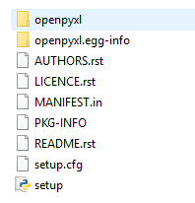in DVD (folder contains below files)
* Then type below command to install openpyxl

            Python setup.py install

* Install Solidworks2017.

**Note:** Only Design calculations can be visualized in the program, ‘View Cad Model’ function will not give output.

1. User with Solidworks And Python installed

* Copy project MD from the DVD to C drive.
* Now run DESIGN OF RIVETS.py from the folder which is copied earlier.

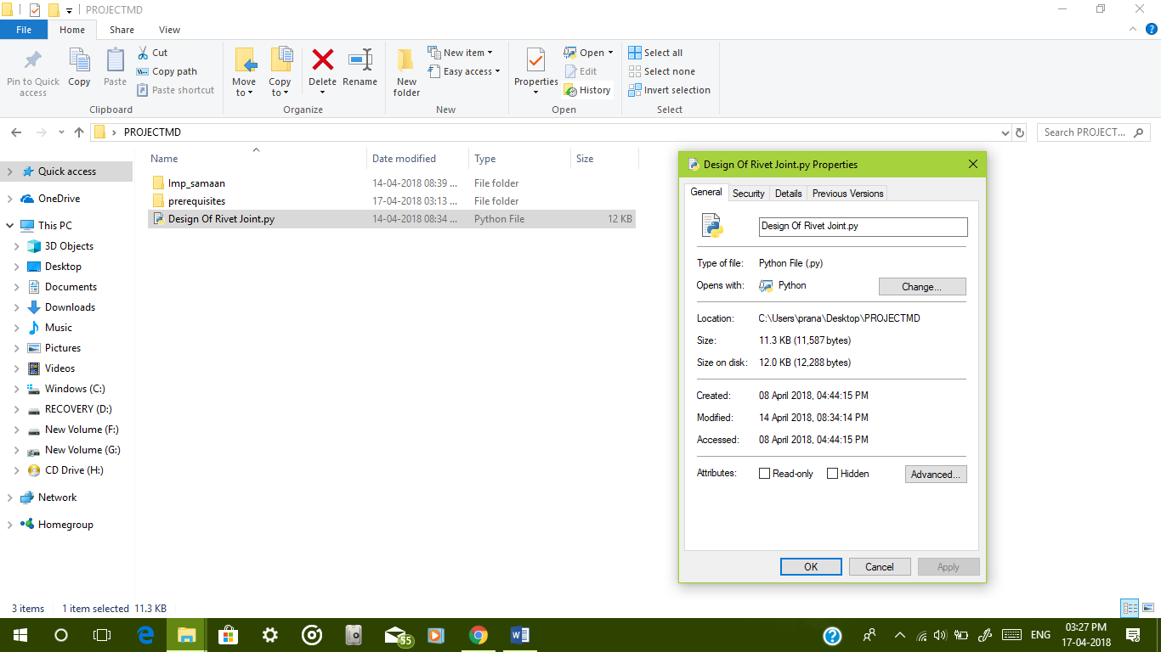

* 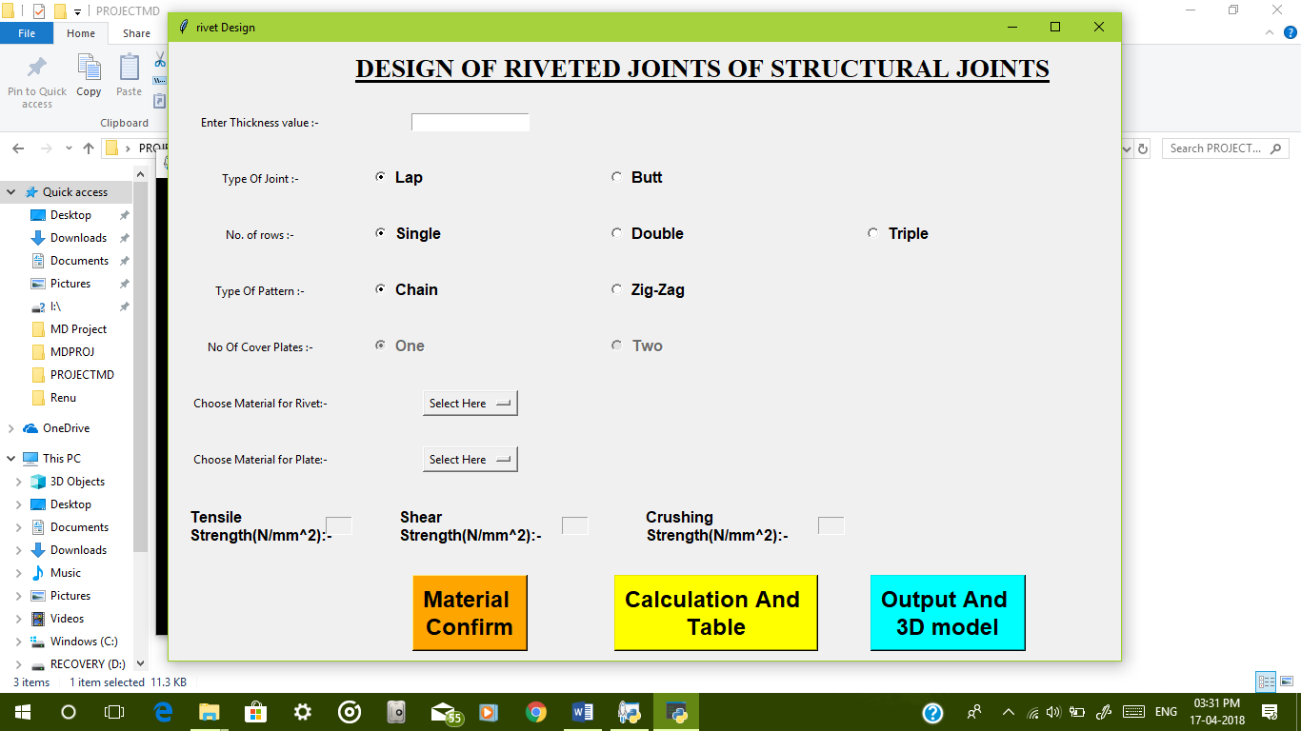Input Screen is Displayed as Below:-
* Provide various input parameters in the application. User can select material from popup menu.
* After selecting Materials hit 'Material Confirm' Button.
* After entering different parameters Hit ‘Calculation and Table’ push button to show the output in table form.
* 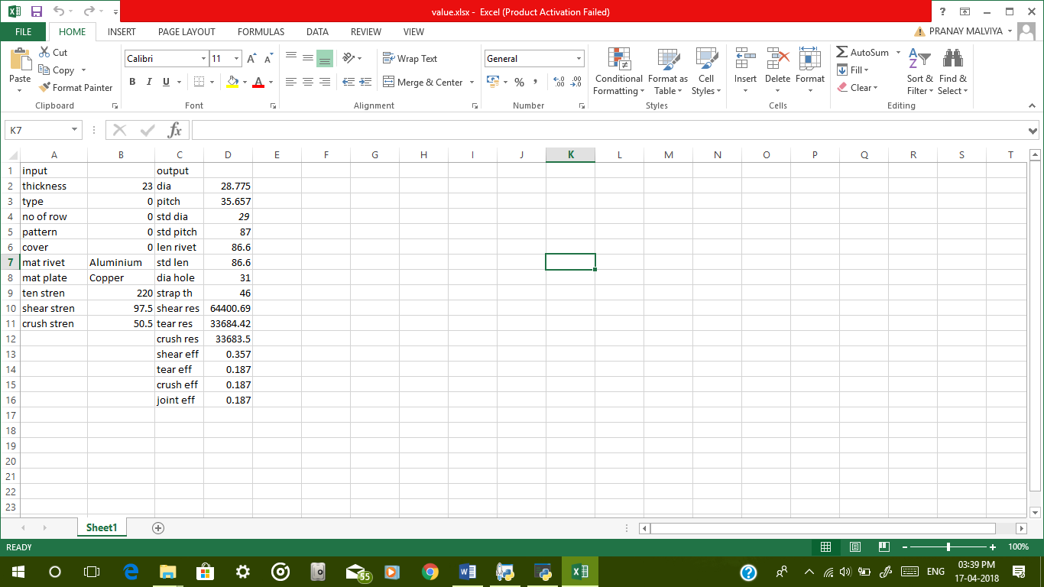The linked table is opened, 'Save' and 'Close' Excel Worksheet.
* Hit 'Output And 3D Model'. Output Screen will appear as shown below

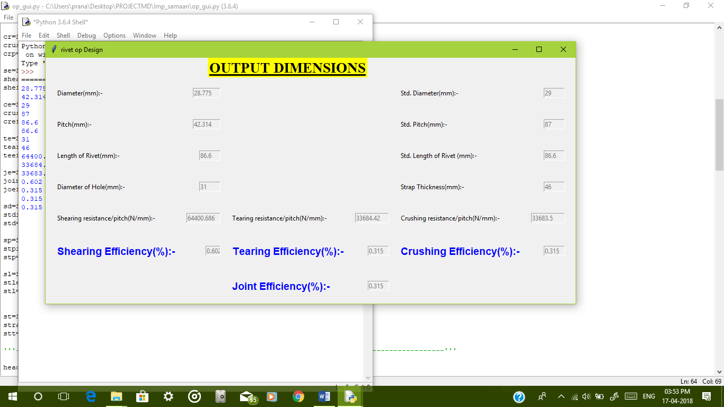

* 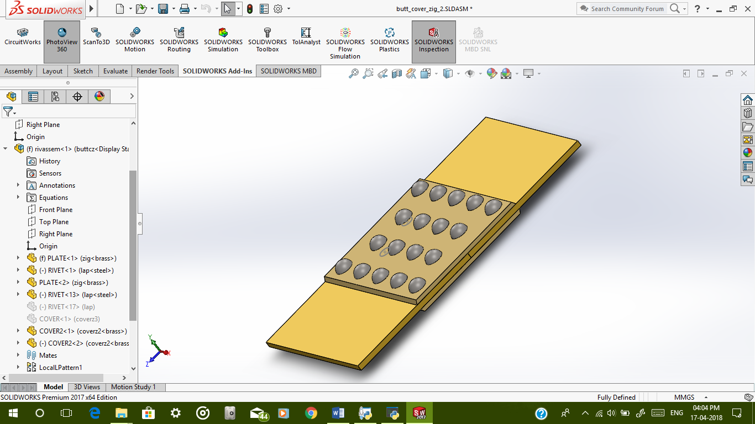After closing Output Screen, Solidworks assembly of given joint and material will appear.
* 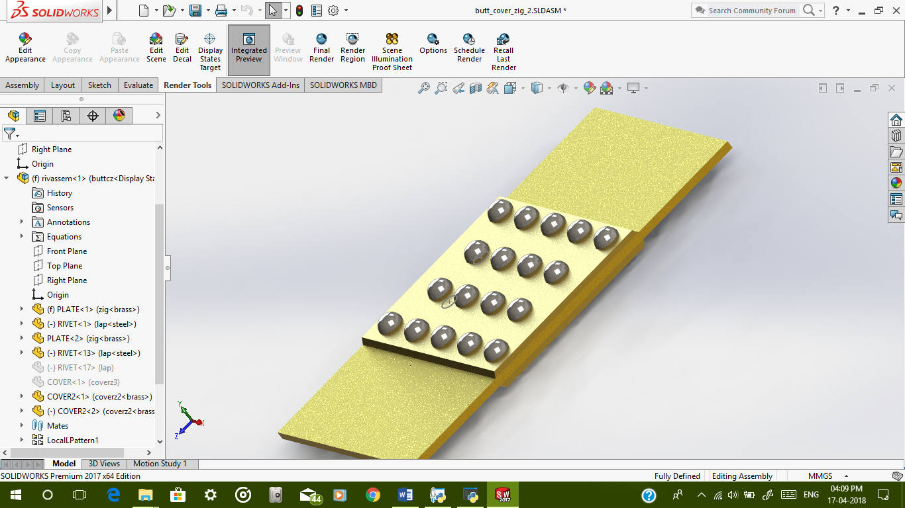To see Rendered View open 'Photoview 360', click on Integrated Preview.

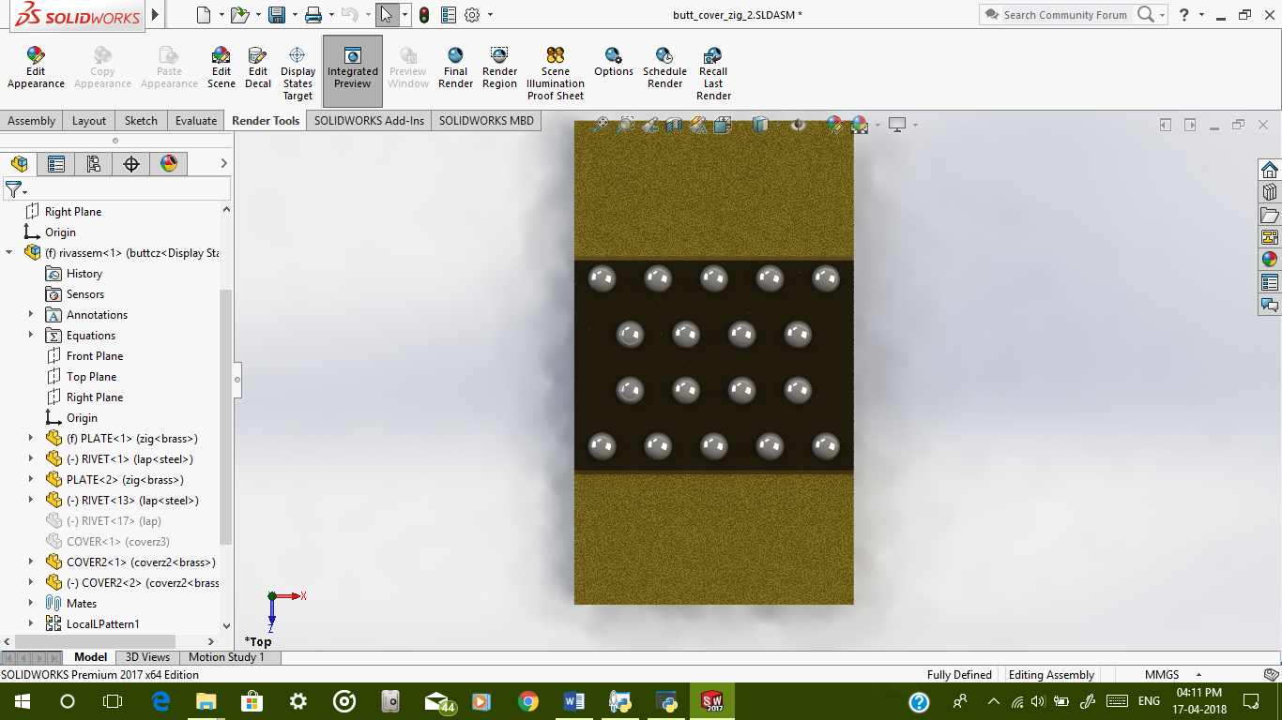

**BACK-END Working/Algorithm used in Coding**

This application works on Python libraries and need Python runtime installed for users without Python.

**How coding of this application is done:**

* Input of different parameters is stored in different variables from the GUI when ‘Material Confirm’ pushbutton is pressed.
* Main code for the program is present in ‘Calculate And View Table’ push button call back function.
* Different materials are stored in Material selection popup menu, whose coding is stored in its call back function.
* Four primary cases present in coding section are:
* Lap joint chain type riveting
* Lap joint ZigZag type riveting
* Butt joint chain type riveting
* Butt joint ZigZag type riveting

Whereas, total number of cases are fifteen. These are assigned with variable, with the help of conditional operators through which cases can be switched.

* Diameter is calculated with the thickness provided.
* Length of rivet with diameter is stored from the excel file in the program.
* Standardisation of diameter is done from the above table.
* Length of the rivet is calculated by adding thickness of plates and 1.3*diameter which is standardised with the table.
* Pitch is calculated as per design procedure and standardised using conditional operators.
* Diameter of hole is calculated as per the PSG design data book using conditional operators.
* Different parameters are calculated and Different efficiencies are calculated.
* At last of the calculations, GUI output’s Static texts (different output variables) are updated as per the design requirement.
* Design table which is exported from the Solidworks is also updated just after the design calculations. As a user select ‘Output And 3D Model' option, respective 3D model of riveting pattern is opened and updated. Synchronisation of assembly takes place which shows the final design of the Riveted joint.

**Limitations of the Program**

This works fine for the purpose of getting Different Design output along with the CAD model. There are some limitations of this program which is negotiable:

* Program can be used only 3 rows of riveting.
* Only applicable to uniaxial based structural applications, not for eccentric loading.
* Number of rivets in each row is fixed to 4 for Chain riveting whereas for ZigZag riveting outermost row have 4 and consecutive row have 5.

**References**

1. V.B. Bhandari. Design of Machine Elements, Third edition, The McGraw-Hill Companies.
2. R.S. Khurmi, J.K. Gupta. A Textbook of Machine Design, Fourteenth edition(2005), Eurasia Publishing House (Pvt.) Ltd.
3. Faculty of Mechanical Engineering, PSG College of Technology. Design Data, Edited and reprinted (June 2016), M/s. Kalaikathir Achchagam.
4. [www.nptel.com](http://www.nptel.com)
5. www.youtube.com
6. www.stackoverflow.com
7. www.pythontutorials.org
8. [docs.python.org](http://www.matlabtips.com)
9. [Lynda](http://www.google.com) Solidworks Tutorials